# **ResourceTBL Database**

Note: I have used MySQL server and MySQL workbench (client application)

1. **Create Statement**

CREATE TABLE ResourceTbl(

Resno varchar(8) NOT NULL,

Resname varchar(50) NOT NULL,

Rate decimal(10,2) NOT NULL,

CONSTRAINT Resnopk PRIMARY KEY(Resno),

CHECK (Rate > 0)

);

Output:



1. **Desc Table**

DESC ResourceTbl;

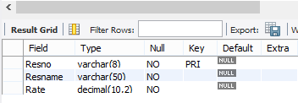

1. **ResourceTbl Table rows**

SELECT * FROM ResourceTbl;

